Ideation Phase
Define the Problem Statements

Date | 28 September 2026
Team ID | 6ab64cc2da631abbf0cd4d07
Project Name | AI WeatherWise API
Maximum Marks | 2 Marks

Customer Problem Statement Template:
Create a problem statement to understand your customer's point of view. The Customer Problem Statement template helps you focus on what matters to create experiences people will love.
A well-articulated customer problem statement allows you and your team to find the ideal solution for the challenges your customers face. Throughout the process, you’ll also be able to empathize with your customers, which helps you better understand how they perceive your product or service.
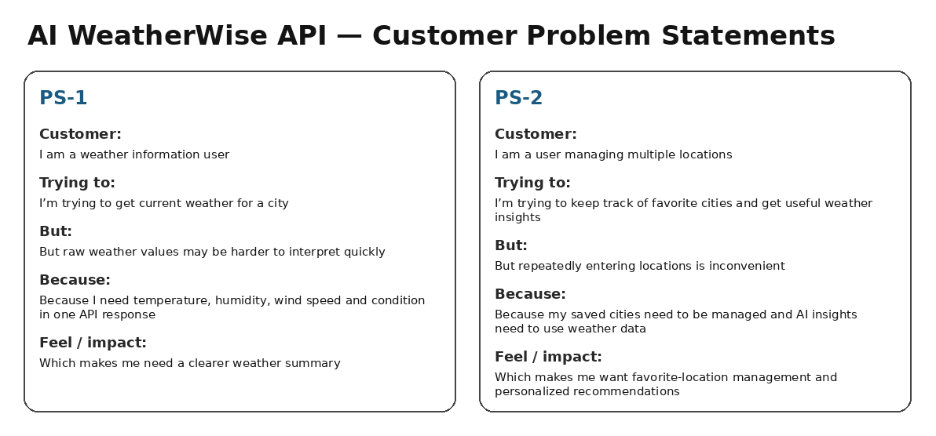
Reference: https://miro.com/templates/customer-problem-statement/
AI WeatherWise Problem Statements:
Problem Statement (PS) | I am (Customer) | I’m trying to | But | Because | Which makes me feel
PS-1 | a weather information user | get current weather for a city | raw weather values may be harder to interpret quickly | I need temperature, humidity, wind speed and condition in one API response | I want a clearer weather summary
PS-2 | a user managing multiple locations | keep track of favorite cities and get useful weather insights | repeatedly entering locations is inconvenient | saved cities need to be managed and AI insights need weather data | I want favorite-location management and personalized recommendations

